Project Design Phase-II
Data Flow Diagram & User Stories

Date | 06-07-2026
Team ID
Project Name | UCab - Cab Booking System
Maximum Marks | 4 Marks

Data Flow Diagrams:
A Data Flow Diagram (DFD) is a graphical representation that explains how data moves through a system. It represents the interaction between external entities, system processes, databases, and the flow of information.
The UCab Online Cab Booking System contains three major modules:
- Admin Module
- User Module
- Driver Module
The system allows users to register, log in, view available cabs, book rides, and manage their bookings. The admin manages users, cars, drivers, and booking information. Drivers can log in, view assigned ride requests, and update the ride status.

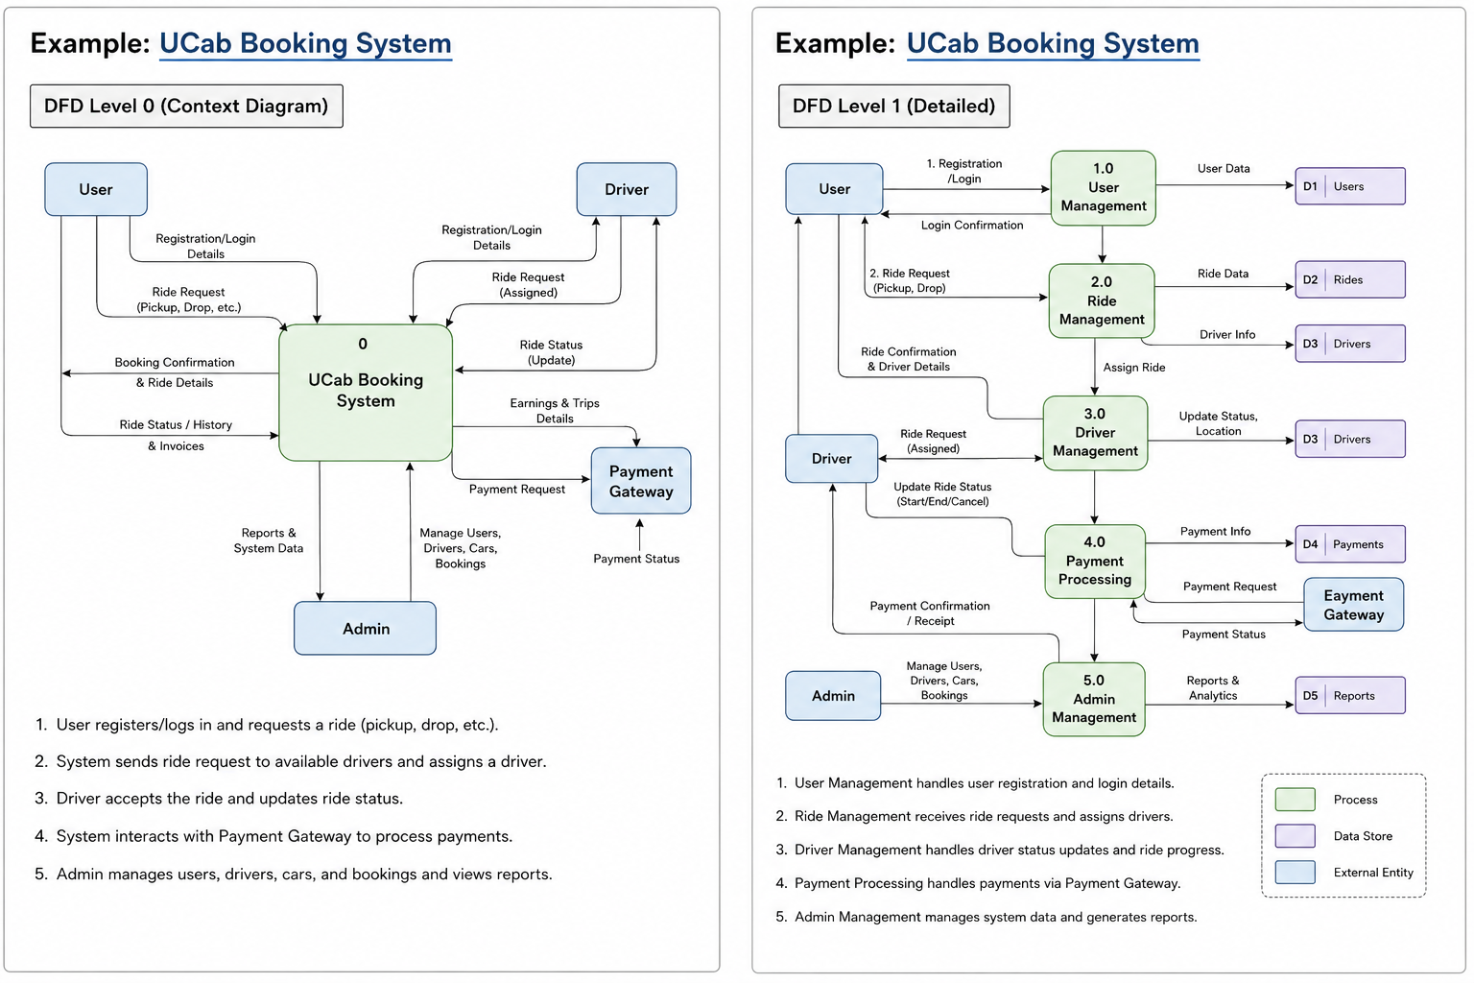
User Stories :

User Type | Functional Requirement (Epic) | User Story Number | User Story / Task | Acceptance Criteria | Priority | Release
User | Registration | USN-1 | As a user, I can register in the UCab application by entering my name, email, password, and phone number. | I can successfully create a new user account and receive a registration confirmation. | High | Sprint-1
User | Login | USN-2 | As a user, I can log in to the UCab application using my registered email and password. | I can successfully log in and access the user home page. | High | Sprint-1
User | View Available Cabs | USN-3 | As a user, I can view the available cab types, models, seating capacity, and price per kilometre. | The system displays all available cabs with correct details. | High | Sprint-1
User | Book a Cab | USN-4 | As a user, I can book a cab by entering the pickup location, destination, journey date, and required cab details. | The booking is created successfully and the booking details are displayed. | High | Sprint-2
User | View Bookings | USN-5 | As a user, I can view the details and status of my cab bookings. | I can view my current and previous booking information. | High | Sprint-2
User | Manage Profile | USN-6 | As a user, I can view and update my personal profile information. | The updated profile information is saved and displayed correctly. | Medium | Sprint-2
User | Logout | USN-7 | As a user, I can securely log out from the UCab application. | My session ends and I am redirected to the landing or login page. | Medium | Sprint-2
Driver | Driver Login | USN-8 | As a driver, I can log in using the email and password provided during driver registration. | I can successfully log in and access the driver dashboard. | High | Sprint-2
Driver | View Assigned Rides | USN-9 | As a driver, I can view the cab bookings assigned to me. | The dashboard displays the assigned ride and customer details. | High | Sprint-3
Driver | Update Ride Status | USN-10 | As a driver, I can update the ride status during the cab journey. | The updated ride status is saved and displayed to the user. | High | Sprint-3
Driver | View Trip Details | USN-11 | As a driver, I can view pickup location, destination, customer details, and trip information. | Complete trip information is displayed correctly. | Medium | Sprint-3
Admin | Admin Login | USN-12 | As an admin, I can securely log in using my registered email and password. | I can successfully log in and access the admin dashboard. | High | Sprint-1
Admin | Dashboard | USN-13 | As an admin, I can view the total number of users, drivers, cars, and bookings on the dashboard. | The dashboard displays the correct count of users, drivers, cars, and bookings. | High | Sprint-2
Admin | Manage Users | USN-14 | As an admin, I can view, edit, and manage registered user details. | User information is displayed and updated successfully. | Medium | Sprint-2
Admin | Add Driver | USN-15 | As an admin, I can register a driver by entering the driver’s name, email, password, phone number, licence number, and assigned car type. | A new driver is successfully added and stored in the database. | High | Sprint-2
Admin | Manage Drivers | USN-16 | As an admin, I can view, edit, and manage driver information. | Driver details are displayed and updated successfully. | High | Sprint-3
Admin | Add Car | USN-17 | As an admin, I can add a car by entering the car type, model, price per kilometre, seating capacity, and image. | The new car is saved and displayed in the available cab list. | High | Sprint-2
Admin | Manage Cars | USN-18 | As an admin, I can view, edit, and delete car information. | Car information is updated or deleted successfully. | High | Sprint-3
Admin | Manage Bookings | USN-19 | As an admin, I can view and manage all cab bookings made by users. | All booking information and booking statuses are displayed correctly. | High | Sprint-3
Admin | Assign Driver | USN-20 | As an admin, I can assign an available driver and car to a user’s cab booking. | The selected driver and car are successfully assigned to the booking. | High | Sprint-3

